

Theses: Docker Containers Deployed Using Bluemix

Name: Thomas Flynn

ID: 16117743

Supervisor: Dr. Sean McGrath

Course: Information & Network Security MEng

Year: 2017

Department: Electronic & Computer Engineering

Table of Contents
1 Abstract 4
2 Introduction 6
2.1 Open Source 7
2.2 Docker Containers 10
2.3 Bluemix Platform 12
3 Container Orchestration 13
New Stack Container orchestration 14
Docker Swarm 17
3.1 Docker Compose 18
3.2 Kubernetes 20
3.3 Bluemix Container Service 23
3 Infrastructure as code 24
.1 Continuous Integration and Delivery Pipelines 25
3.1 Chef 26
3.2 Puppet 26
3.4 Ansible 27
3.5 Salt 28
2.6 Travis CI tool 29
2.6 Jenkins 30
2.7 Slack 31
2.8 TeamCity 31
2.9 Rational Team Concert 31
4.10 Git lab 32
Continuous Delivery 33
.10 Urbancode Deploy 33
6.3 Smart campus open source project (DevOps) 35
6.4 Smart campus mobile applications using Ionic library 36
6.5 Library,car park, Gym sensor/public API 37
6.6 Graph database design for both a WSN and/or student survey application 37
6.7 Migration of a monolithic app to a microservices app using Istio 37
6.8 38
2.2 Dan Geer on Open Source and IoT security related issues 42

1 Abstract
How to effectively manage increasingly complex enterprise computing environments is one of the hardest challenges that most organizations have to face in the era of cloud computing, big data and IoT. Advanced automation and orchestration systems are the most valuable solutions helping IT staff to handle large-scale cloud data centers. Containers are the new revolution in the cloud computing world, they are more lightweight than VMs, and can radically decrease both the start up time of instances and the processing and storage overhead with respect to traditional VMs. The aim of this paper is to provide a comprehensive description of cloud orchestration approaches with containers, analyzing current research efforts, existing solutions and presenting issues and challenges facing this topic.

2 Introduction
Themes: Containers, DevOps, IoT

Following recent technological advancements in software systems, like microservices, containers and cloud systems, DevOps has risen as a new development paradigm. Its aim is to bridge the gap between development and management of software systems and enable continuous development, deployment and integration. Towards this end, automated tools and management systems play a crucial role.
As Docker containers become a standard tool for developers, organizations need to find a container management solution that developers can use to build cloud native apps locally yet can scale to become a global cluster managed by operations.
http://dl.acm.org/citation.cfm?id=3105514

2.1 Open Source
Over the past twenty years, open source software has emerged as a major force throughout our information-driven economy. Open source practices have dramatically changed the way software is developed. And now we have an unending array of tools and Internet-based services that make it possible, if not downright easy, for nearly everyone to create and distribute useful, important software.
Open source is based on freedom. That freedom includes access to the source code, freedom to collaborate, and ultimately, the freedom to innovate. In open source, no one person or company owns a project. Open source is a philosophy and a movement, and what makes open source thrive is the community that grows up around it. https://thenewstack.io/power-community-open-source/

2.1.1 IBM’s approach to open technology
IBM has a long history of working in open technology. IBM's strong support for Linux with patent pledges and significant technical resources and investment in the face of some of the legal uncertainty surrounding its use—brought about a change in posture toward open source for many enterprises. Under the right circumstances, open source can be a compelling and trusted adjunct to proprietary software
IBM's commitment and contribution to open source is unrivaled in the industry. They have worked hard over the years to establish a solid and respected reputation in open source circles. They work hard to invest in ensuring interoperability, portability, and various other enterprise characteristics by investing in the community and helping to shape programs that can help deliver those characteristics. They value and work toward open governance because they feel that this is the best way to ensure the long-term success and viability of open source projects. Thousands of IBM developers are working every day in open source projects that matter.
IBM evaluates open source projects by looking closely at five aspects of the project:
- Responsible licensing—They look to understand the open source license that is associated with the technology.
- Accessible commit process—They seek to ensure that there is a clearly defined process for making contributions that welcomes outside contributors.
- Diverse ecosystem—They confirm that there are multiple vendors and ISVs that are delivering offerings based on the technology.
- Participative community—They require that there be a process for contributors to grow their technical eminence in the community.
- Open governance—They evaluate the governance model to determine whether it is truly open.

https://www.ibm.com/developerworks/cloud/library/cl-open-architecture-update/

2.1.2 Node.js Foundation
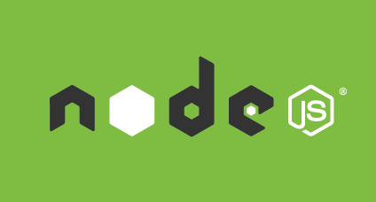
In 2014, the Node.js community went through a dark period where the community developing the technology suffered a schism and forked into two independent projects: Node.js and io.js. Because of IBM's reputation in the open communities, they were asked to help resolve the differences. IBM worked within both communities to bring the factions together under a single open governance model at the Node.js Foundation under the Linux Foundation's collaborative projects program. The community has reconciled, and it is on a steady cadence of long-term and experimental releases. IBM helped to heal the fork and bring the community back to a single, unified code base. IBM is also one of the leading contributors to the Node.js community.

2.1.3 OpenStack
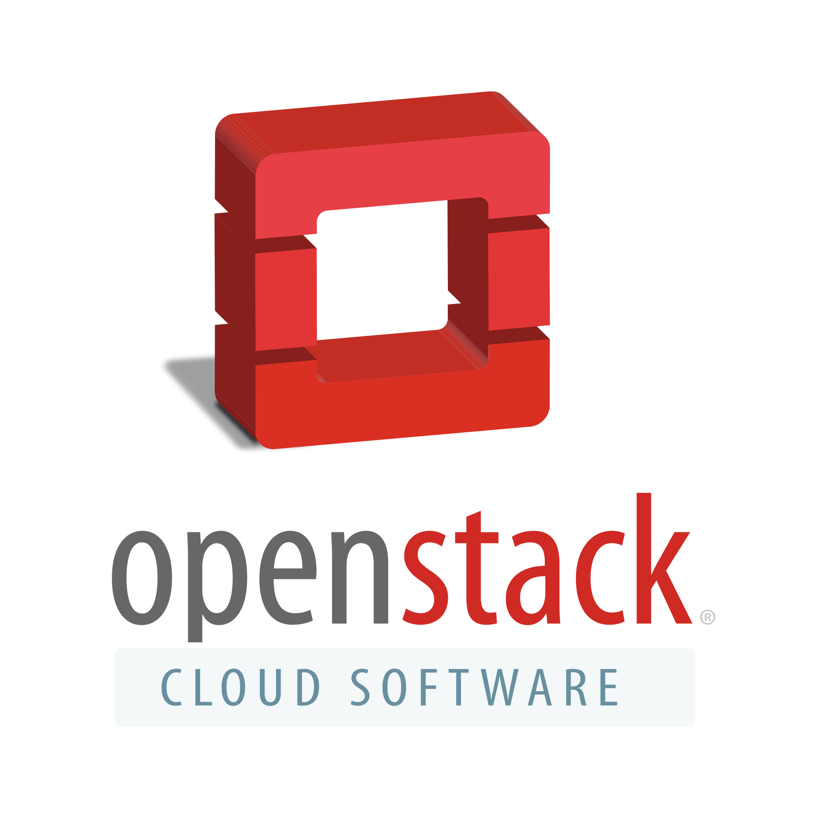
Figure 16
In 2012, IBM collaborated with AT&T, Canonical, HP, Intel, Rackspace, Redhat, and SUSE (among others) to establish the OpenStack Foundation. Its goal is to provide an open governance framework for OpenStack.

2.1.3 Open Container Initiative
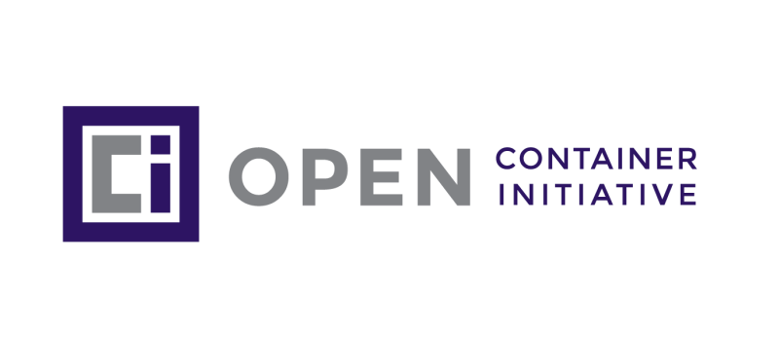
Figure 14
The Open Container Initiative (OCI) is a lightweight, open governance structure (project), formed under the auspices of the Linux Foundation, for the express purpose of creating open industry standards around container formats and runtime. The OCI was launched on June 22nd 2015. [12]
The project gained wide attention because of the promise of portability, agility and interoperability in a broad range of infrastructures.

2.1.4 Cloud Native Computing Foundation
The Cloud Native Computing Foundation (CNCF) is a nonprofit organization committed to advancing the development of cloud native technology and services by creating a new set of common container technologies informed by technical merit and end user value, and inspired by Internet-scale computing. As a shared industry effort, CNCF members represent container and cloud technologies, online services, IT services and end user organizations focused on promoting and advancing the state of cloud native computing for the enterprise. [13]

Figure 15

2.2 Docker Containers
Released as an open source project in 2013, Docker has rapidly achieved widespread use. It was originally designed to access Linux kernel namespace features via LXC, but has switched to use its own “libcontainer” library that directly accesses the kernel. In addition to creating containers, Docker provides mechanisms to deploy applications into the containers with a “Dockerfile”. Docker supports a variety of storage backends, most support copy-on-write semantics. Layered filesystems make it possible for multiple containers to run on the same underlying base image. When a container is started from an image, it uses the filesystem of that image. Modifications to the filesystem by a process in the container are written to a filesystem specific to that container, which makes it possible to run multiple containers independently on top of a single image. This copy-on-write mechanism (in contrast to a complete copy of the root file system for each container) makes the deployment of containers very fast, and reduces disk and RAM occupancy. The Dockerfile deployment process makes use of this by creating a new image from an existing base image (i.e., a filesystem layer), adding additional layers that describe differences between the base image and the fully deployed application. Docker’s popularity is due, at least in part, to an included system that handles revision control; this system makes it very easy to share docker images via public (such as the default Docker Hub repositories) or private repositories. Typically, public repositories are hosted for free, while the private repositories are not. Docker creates an abstraction for machine-specific settings such as networking, storage, logging, and Linux distribution.
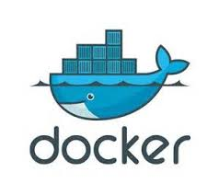
Figure 2
Linux containers are gaining more and more popularity because they are more lightweight than VMs. They are light-weight because container images do not require the inclusion of an entire kernel and thus are much smaller than Vms. Starting a container consists of forking a process and inserting it into a new cgroup. VMs, on the other hand, require execution of a full boot process at startup. Because containers are so lightweight compared to VMs, container virtualization can now be used for scenarios where the use of Vms would have been too expensive. Compared to running processes directly on the host (bare metal), Docker containers (using aufs, a union filesystem) exhibit marginal overhead with respect to performance. In contrast, virtualization with the KVM hypervisor imposes
a much higher overhead. In cases where virtual machines can be replaced with linux containers, containers can improve the overall system performance [7].
https://pdfs.semanticscholar.org/4ea0/9db38a6fd7f23ea7c71f85074464eaff0b37.pdf

2.3 Bluemix Platform
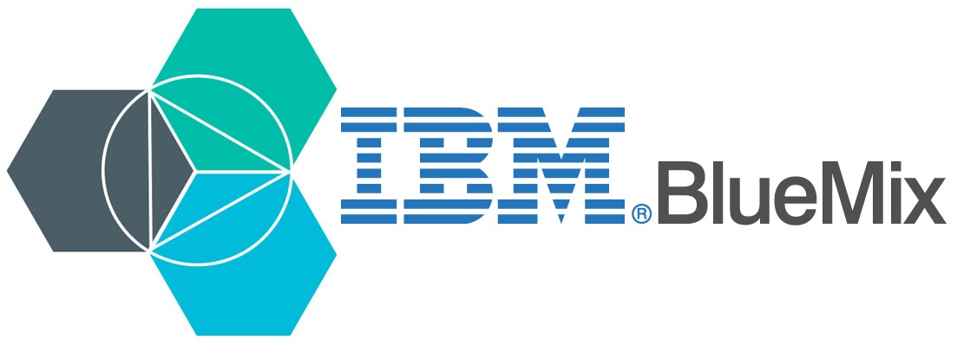
IBM and Docker offer integrated container solutions that can meet the diverse needs of enterprises. Supporting the creation and deployment of multi-platform, multi-container workloads across hybrid infrastructures, IBM and Docker accelerate application delivery and enable application lifecycle management for Dockerized containers. Bluemix also offers the following services.

.1 DevOps Services
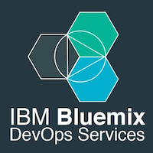
Easily deliver code and seamless track changes from all developers. Each project gets a Git repository or a Jazz source code management repository and workspace where project members check in changes, associate code changes with work items, and view a history of recent updates.

.2 Node-RED
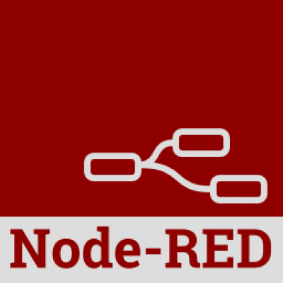
Node-RED is a tool for wiring together the Internet of Things in new and interesting ways, including hardware devices, APIs, and online services. It is built on top of Node.js and takes advantage of the huge node module ecosystem to provide a tool that is capable of integrating many different systems. Its lightweight nature makes it ideal to run at the edge of the network.

.3 OpenWhisk

The OpenWhisk serverless architecture accelerates development as a set of small, distinct, and independent actions. By abstracting away infrastructure, OpenWhisk frees members of small teams to rapidly work on different pieces of code simultaneously, keeping the overall focus on creating user experiences customers want.

.4 Cloudant

IBM Cloudant is a managed NoSQL JSON database service built to ensure that the flow of data between an application and its database remains uninterrupted. Developers are then free to build more, grow more.

.5 Watson
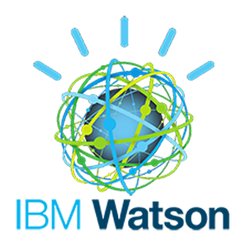
IBM Watson is a technology platform that uses natural language processing and machine learning to reveal insights from large amounts of unstructured data.IBM Watson is a technology platform that uses natural language processing and machine learning to reveal insights from large amounts of unstructured data.

3 Container Orchestration
The concept of containers has existed for over a decade. Mainstream Unix-based operating systems such as Solaris, FreeBSD and Linux, has built in support for containers, but it was Docker that truly democratized containers by making them manageable and accessible to both the development and IT operations teams. Docker has demonstrated that containerization can drive scalability and portability of applications.
Developers and IT operations are turning to containers for packaging code and dependencies written in a variety of languages. Containers are also playing a crucial role in DevOps processes. They have become an integral part of build automation and continuous integration and continuous deployment (CI/CD) pipelines.
While core implementations center around the life cycle of individual containers, production applications typically deal with workloads that have multiple containers running across dozens of hosts.
The complex architecture dealing with multiple hosts and containers running in production environments demands a new set of management tools. Some of the popular solutions include Docker Datacenter, Kubernetes, and Mesosphere DC/OS.
Container orchestration has influenced traditional Platform as a service (Paas) archiecture by providing an open and efficient model for packaging, deployment, isolation, service discovery, scaling and rolling upgrades. Most mainstream PaaS solutions have embraced containers, and there are new PaaS implementations that are built on top of container orchestration and management platforms. Customers have the choice of either deploying core container orchestration tools that are more aligned with IT operations or utilizing a PaaS implementation that targets developers.
The key takeaway is that container orchestration has impacted every aspect of software development and deployment. Kubernetes will play a crucial role in driving the adoption of containers in both enterprises and emerging startups.

New Stack Container orchestration
Running clusters and orchestrating thousands of containers is an entirely new game. It puts software at the center stage, with a greater need to monitor components rather than the application itself.
It’s a world that requires an advanced appreciation of automation via APIs, and orchestration that takes into account the need for scheduling, cluster management and a host of other matters, such as securing nodes, health checks and prioritization.
Today we see how orchestration for containers changes the lens of how we view applications. Microservices orient developers to focus on services and how those services differentiate applications. Containers are catalysts for making these applications behave according to the components on distributed clusters. Apache Mesos, Docker Swarm, HashiCorp Nomad and Kubernetes are good examples of this. They help systems operators model their clusters and make services accessible.
Many software companies have built platforms that are entirely ephemeral. For companies adopting elastic, scaled-out platforms, the concept is often about how to eliminate the VM entirely, build on bare metal and create container-based clusters.
This all adds up to a change in how we think about automation and orchestration. But one principle remains: there’s a push to implement programmable infrastructure, applying methods and tooling established in software development onto the management of IT infrastructure, across thousands of clouds. It’s a movement that will lead to any number of new practices and discoveries.
The software industry at large has failed to truly implement ideas behind programmable infrastructure, said Solomon Hykes, Docker founder. It’s difficult to become an effective developer without ten years or more of programming experience. Scale needs to be at the scale of the Internet, Hykes said. “So clustering, orchestration, networking between containers, storage across more than one container, that shared storage, security, things like that, verification of contents so that you can track the authenthicity and provenance of the containers you’re about to deploy,” Hykes said. “All of these are part of the problem of building and deploying distributed applications. So it’s a big list of problems and you need a combination of tools to address these problems. And you need those tools to integrate. They need to work together to form a platform, otherwise you’ve got a giant puzzle and the pieces will never fit together.
Docker and containers are processes. They make delivering components easier. A container does not carry an operating system with it. That makes the container lighter and easier to manage. It does not require configuration to the machine itself. And a container is disposable — it embodies the concept of immutable infrastructure; live instances are never directly changed, but rather replaced as their configuration changes due to their lightweight and easy reproducibility, containers, in their current packaged form, introduce new complexities previously not understood.
With containers comes a change in the role that data centers will play. The research and development that has existed internally will move outwards into open source communities.

Removing Dev and Ops wall
The software will in turn, continue to get developed even faster built as integrated technologies for the developer and the operations person, who can no longer separate their duties. There is no wall anymore between Dev and Ops, just a pipeline of continuous delivery.
Removing that wall between Dev and Ops is the most important shift of all that will come as container adoption becomes more widespread, accelerated by open source development. The software required to manage clusters will be the orchestration platforms, working on data planes that make container-based clusters fully mobile. The infrastructure itself becomes centered on the application.

Cloud-Native
The concept of cloud native has set the stage for how organizations develop a programmable infrastructure, and the complexity is astounding. There are a number of overlapping domains, especially when we think about container management, said Chris Ferris, distinguished engineer and chief technical officer of open technology at IBM Cloud in an interview with The New Stack.
This overlap may lead to different integrations that allow customers to build from components that suit their needs, and potentially an architecture that everybody can agree upon. What is needed is fault tolerance, self healing, easy roll-outs, versioning, and the ability to easily scale up or down. Containers should run on a cloud service or your own hardware — and have them just run at whatever scale is necessary, never going down and never paging the Ops team. This is what people call orchestration.

Orchestration and Automation
“I think largely, when we think about automation, you think about writing the scripts that are integrated into a platform, like Chef, Jenkins or Ansible ...that is actually driving the actual behavior; and we think about orchestration as the platforms themselves that are providing that facility to be able to orchestrate the order in which things are going. That’s the orchestration. The automation itself is just the actual execution of the point-in-time script.”- Christopher Ferris

Orchestration
Orchestration helps to complete the end-to-end DevOps pipeline in many ways. For the developer, it starts with the local environment on their laptop. But for the platform to work, it necessitates automation of the entire infrastructure. It is not just about continuous integration and continuous delivery. It’s about container operations, which speaks to the concepts of DCOS, the datacenter operating system developed by Mesosphere. DCOS provides an operating system that abstracts the resources of an entire cluster of machines and makes them available to the developer like one big box, said Michael Hausenblas, a datacenter application architect and DevOps advocate at Mesosphere. Frameworks run on DCOS.

Conclusion
Dev and Ops teams closer together than ever before. And even as the space begins to change, and reviews about the role of VMs and containers in automated environments at scale matures, there is still much to be learned about managing virtualized environments; this space is still a new one for many users and vendors alike, and there are many unknowns, but that just places greater emphasis on the need to manage and orchestrate the various components. From automation and orchestration to scheduling, cluster management, service discovery, security and more, it all adds up to a change in how we think about automation and orchestration. Embracing this change, and learning to focus on developing best practices, is a larger journey for the entire container ecosystem; a journey fueld by open source, the need for for connectivity, passionate communities of users, and economic factors in the business models of vendors.

Docker Swarm
Docker Swarm is Docker’s native offering for orchestration. With Docker 1.12, it added the “swarm mode” feature for orchestrating across multiple hosts. Docker Swarm remains a separate product. It can be accessed via the Docker API and used to invoke tools like docker compose for declarative orchestration of services and containers. Docker Swarm forms part of a bigger offering - the Docker Datacenter that is aimed at enterprise container deployments.

3.1 Docker Compose
Docker Compose is a tool for defining and running multi-container Docker applications. With Compose, you use a Compose file to configure your application’s services. Then, using a single command, you create and start all the services from your configuration.
Compose is great for development, testing, and staging environments, as well as CI workflows.
Using Compose is basically a three-step process.
- Define your app’s environment with a Dockerfile so it can be reproduced anywhere.
- Define the services that make up your app in docker-compose.yml so they can be run together in an isolated environment.
- Lastly, run docker-compose up and Compose will start and run your entire app.
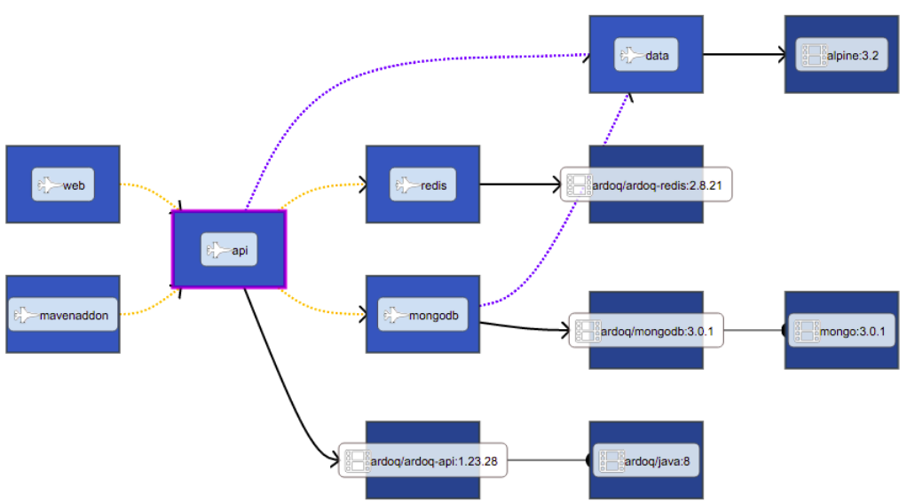
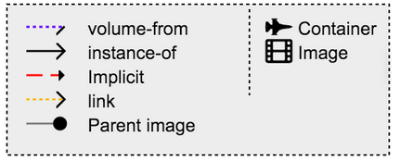
The real advantage of Compose is for applications that revolve around a single-purpose server that could easily scale out if architectural complexity is not a requirement. Development environments, which tend to use an all-in-one method of operation, fit well into this requirement. The community's reception of Compose has been notably positive, but the practicality of its usage and the lack of ability to create a long-term vision around it tend to minimize the actual legitimacy of adopting it as a container orchestration technology.

Container ecosystem

Cloud Foundry
Cloud Foundry is an open source cloud platform as a service (PaaS) on which developers can build, deploy, run and scale applications on public and private cloud models. VMware originally created Cloud Foundry and it is now part of Pivotal Software.

Figure 13
Cloud Foundry is licensed under Apache 2.0 and supports Java, Node.js, Go, PHP, Python and Ruby. The open source PaaS is highly customizable, allowing developers to code in multiple languages and frameworks. This eliminates the potential for vendor lock-in, which is a common concern with PaaS.

runC

runC, a lightweight universal container runtime, is a command-line tool for spawning and running containers according to the Open Container Initiative (OCI) specification. That's the short version. The long version: The governance umbrella created by Docker, Google, IBM, Microsoft, Red Hat, and many other partners to create a common and standardized runtime specification has a readable spec document for the runtime elements of a container, and a usable implementation based on code contributed to the OCI by Docker. It includes libcontainer, the original lower-layer library interface originally used in the Docker engine, to set up the operating system constructs that we call a container.
Given that runC is an open source project with a regular release cadence, you can find the code and respective releases on GitHub. If you download or build the runC binary you will have everything you need to get started using runC as a simple container executor based on the runtime spec elements: a JSON container configuration and a root filesystem bundle. Note that if you have an installation of Docker 1.11 or above you will automatically have a recent copy of runC installed on your system as well. It is most likely named docker-runC and installed in /usr/bin, and can be used outside of Docker just like any normal installation of runC.
https://opensource.com/life/16/8/runc-little-container-engine-could

Embeddable
Containers are started as a child process of runC and can be embedded into various other systems without having to run a daemon.

Battle Hardened
runC is built on libcontainer, the same container technology powering millions of Docker Engine installations.

Unopinionated
runC does not force you to have a particular workflow or deployment setup, it only requires a root filesystem and configuration.

Benefits of using runC
Even before the OCI and runC existed, many core Docker engine developers used a runC-precursor, nsinit, that allowed a simplified entry point into running and debugging low-level container features without the overhead of the entire Docker daemon interface. Now that runC exists, this is definitely one continuing use case, especially for someone potentially exposing a new Linux isolation feature. For example, the checkpoint/restore capability using the Linux Checkpoint/Restore In Userspace (CRIU) project first was made available via runC, and just now is being prepared for addition to the Docker daemon at the layer above runC. Of course, as runC/OCI expands beyond Linux this will be true for other operating system (OS) isolation primitives, such as Solaris zones or Microsoft Windows-based containers, both of which expect to have capabilities via the OCI runtime spec and runC implementation.
Beyond new feature development at the operating system layer, runC is a useful debug platform for finding hard-to-solve bugs that are trickier to debug with the entire Docker stack above the container process.

Garden
Today, Julz Friedman (an engineer from IBM and the Anchor for Cloud Foundry’s Garden project) posted an important update from the Garden project team to the cf-dev mailing list about the future of the Garden project’s approach to the Linux container runtime. TL;DR here is that the Garden project will be transitioning from it’s own backend for Linux containers to using runC from the Open Container Initiative.
Garden? What’s that?
Garden is the containerisation layer used by Diego. Garden provides a platform-neutral, lightweight container abstraction that can be backed by multiple backends (most importantly, a Linux backend and a Windows backend). Currently the linux backend is based on our own code which evolved from Warden and which has been used to power Cloud Foundry for many years. Garden enables diego to support buildpack apps and Docker apps (via the Linux backend) and windows apps (via the Windows backend).
So: What’s changing?
We’re planning to use runC as the Linux backend for Garden.
Why?
Garden has always been an unopinionated container system – we like to have the opinionation happen at the higher levels (i.e. in Diego). Docker, on the other hand, is quite an opinionated container technology: it tightly couples containerisation and the user experience (which is one of the reasons Docker is so great to use, I’m not knocking Docker here!). Recently, Docker and others (including IBM and Pivotal) have come together under the Open Container Initiative to spin out an unopinionated common containerisation runtime, “runC”, which gives us a fantastic opportunity to be part of this community while letting us ensure we can retain the flexibility required by our broader use cases. RunC is a reference implementation of the Open Container spec, which means both Docker and Cloud Foundry will be running the same code, and both Docker and Cloud Foundry apps will be using Open Containers.
Using runC as the garden backend has two major advantages. Firstly it lets us reuse some awesome code and be part of the Open Container community. Secondly it means CF applications will be using not only the same kernel primitives as Docker apps (as they already are today), but also the exact same runtime container engine. This will minimise incompatibility for our Docker lifecycle and result in a first class experience for users, as well as letting us reuse and contribute back to a great open-source code base. We have some remaining features in the Garden Linux backend that we’d like to see in RunC, but we’re excited to engage with the Open Container community to close these gaps.
What about regular CF buildpack apps and the other nice features of Garden?
Moving to runC gives us all the above advantages without compromising our ability to also deliver the buildpack-based platform-centric workflows that make CF great. We will retain the garden abstraction to make it easy for Diego to support both buildpack apps, windows apps and Docker apps, and we will maintain a small layer above runC to manage the containers, pull down native warden and Docker root filesystems, let us perform live upgrades and so on.
Why not use the full docker-engine as the backend?
Docker-engine has both more capabilities than we need at the layer Garden runs and different opinions than Cloud Foundry currently requires. This means it’s harder for us to maintain (because it’s larger and does more stuff), harder for us to contribute to (for similar reasons) and for some of our use cases (particularly with Diego’s more generic lifecycles) we’d have to actively work around things that would be quite easy to expose if we use runC directly (for example docker-engine intentionally doesn’t support signalling `docker exec`ed processes, which is required by Diego).
Most of the reasons you might want to use docker-engine (e.g. being able to ‘docker push’) make much more sense to expose at the platform level in a multi-host environment (you want to push to the cluster, not a single host) or need to be integrated with multi-tenancy (which again should happen at the platform level – you need access control on storage and networks to integrate with the rest of a multi-tenant platform). For these reasons Cloud Foundry prefers to implement many features at the Diego layer whereas docker-engine implements some of these capabilities at the host layer. As the capabilities for running distributed applications in containers continue to evolve, CF prefers the flexibility to implement the opinions of our developers and community for areas like networking and storage even if those may differ from other orchestration solutions like docker-engine, and in turn Garden needs to retain that flexibility.
We also note that many new features have come to runC first (e.g. criu snapshot restore and – importantly for us – user namespaces were first available in runC before being added to docker-engine; at the time of writing these are still not fully available in docker-engine). We’d like to be able to consume new features as they come out in runC, rather than waiting for them to make it in to docker-engine. We also hope to be contributing new features of our own and this is much easier for us to accomplish against the smaller surface area of runC, and within the open context of the Open Container Initiative.
https://www.cloudfoundry.org/garden-and-runc/

3.2 Kubernetes

2.1.1 About Kubernetes
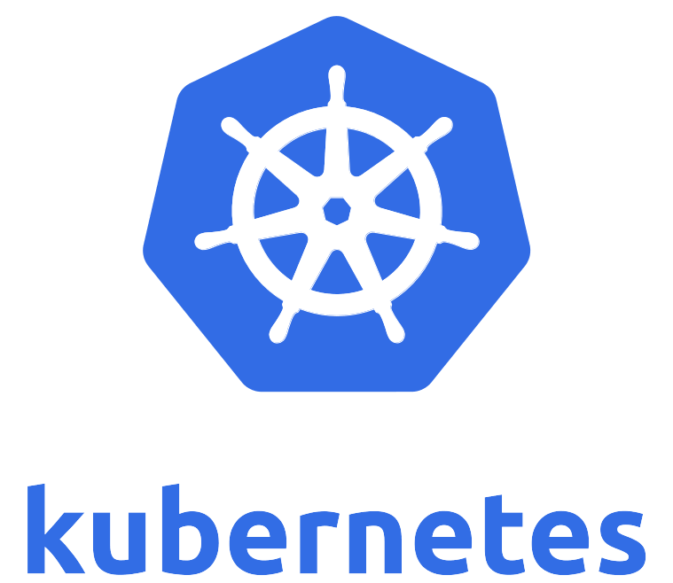
Since the launch of Kubernetes in 2014, IBM has been a contributor to its development, which was built by the open community. By pairing a Docker-powered engine with the simple management capabilities of Kubernetes, Bluemix developers can access a highly usable interface and dashboard to easily write code within a container and quickly deploy it to multiple apps. This clear view also enables developers to see where and when their code is running at any given point in time.
IBM released a beta of Kubernetes support in the IBM Bluemix Container Service on March 19, 2017. The IBM Bluemix Container Service, now combines Docker and Kubernetes to deliver powerful tools, an intuitive user experience, and built-in security and isolation to enable rapid delivery of applications all while leveraging Cloud Services including cognitive capabilities from Watson.
Using a single Kubernetes dashboard you can manage security compliance throughout your DevOps pipeline by automatically scanning both Docker images and live containers for known vulnerabilities and the presence of malware. Verify appropriate container settings and application configurations. Review risk ratings and match container service policies to those of your organization.
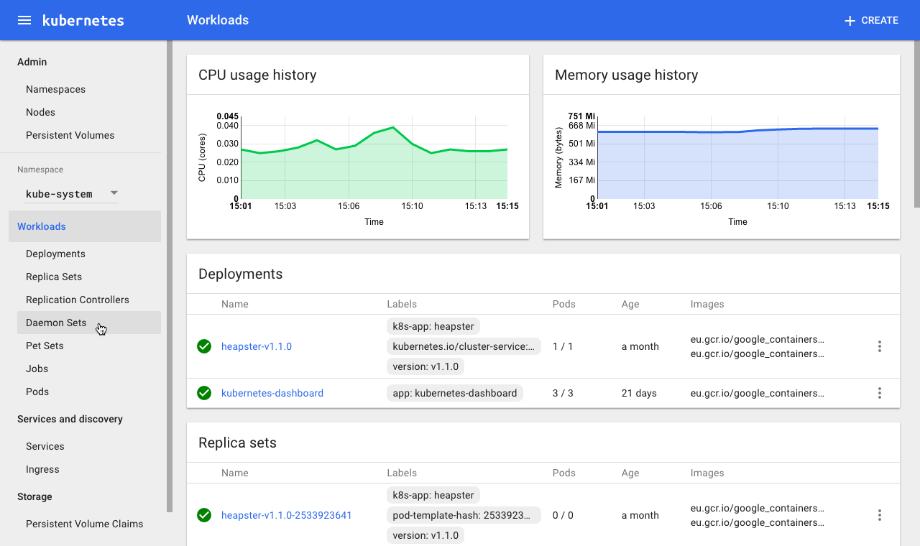

2.1.2 Kubernetes Architecture
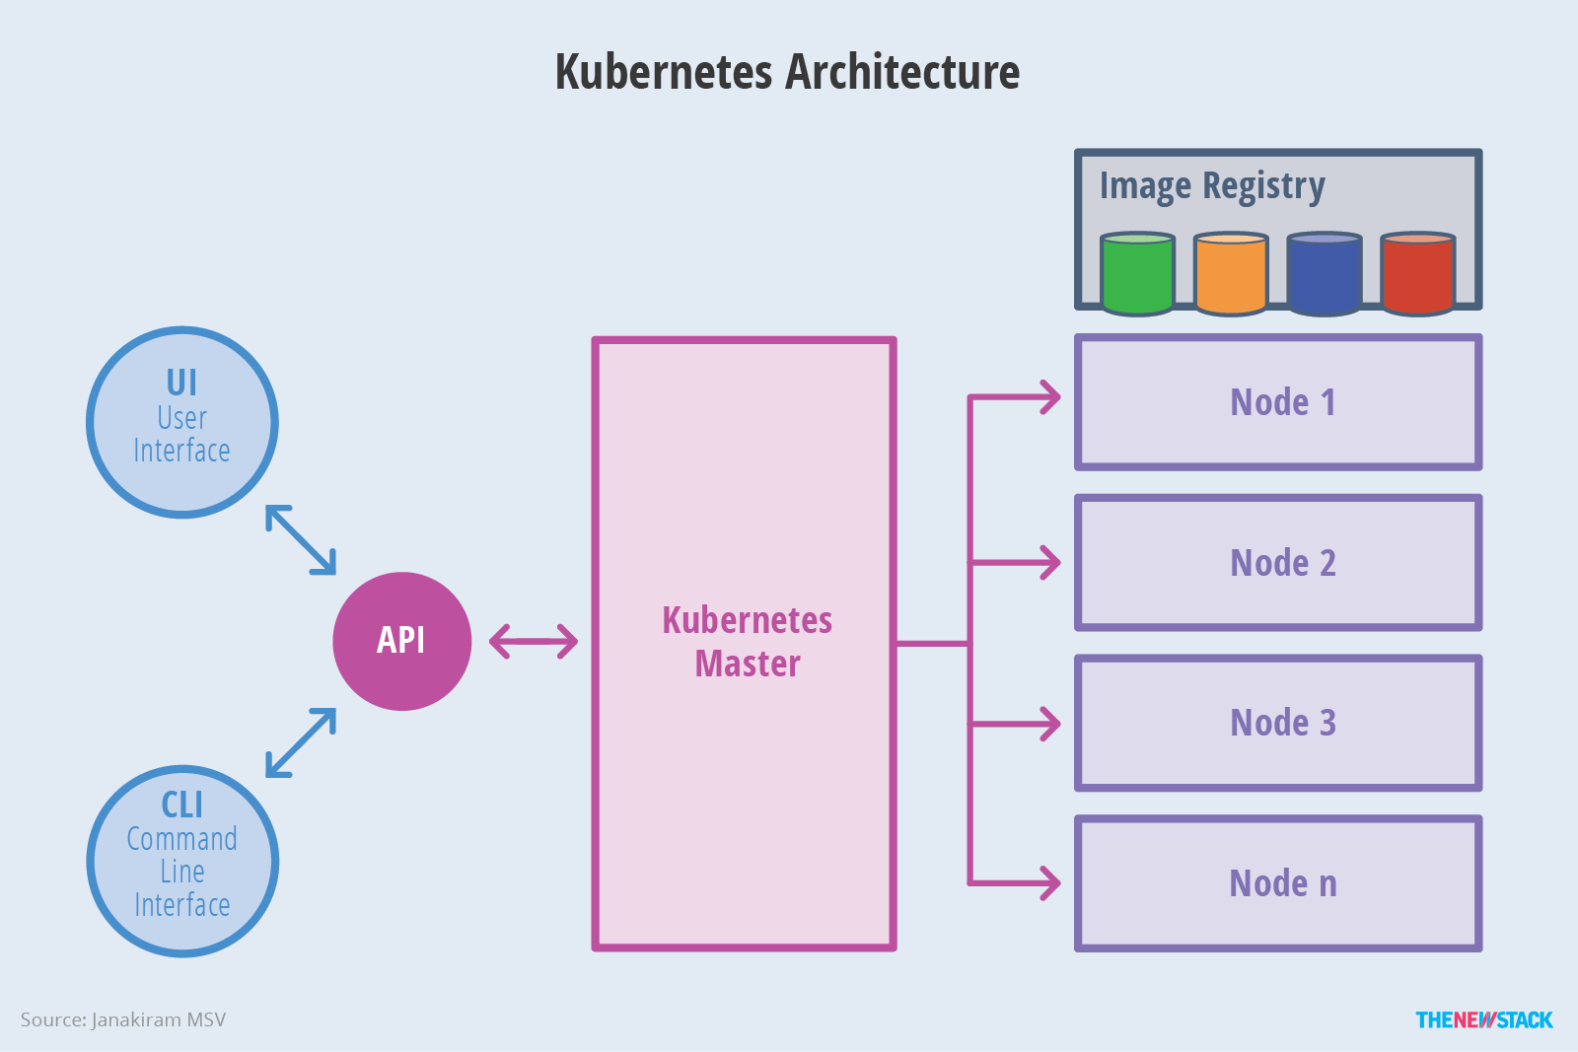
The master is responsible for exposing the application program interface (API), scheduling the deployments and managing the overall cluster. Each node runs a container runtime, such as Docker or rkt, along with an agent that communicates with the master. The node also runs additional components for logging, monitoring, service discovery and optional add-ons. Nodes are the workhorses of a Kubernetes cluster. They expose compute, networking and storage resources to applications. Nodes can be virtual machines (VMs) running in a cloud or bare metal servers running within the data center.
A pod is a collection of one or more containers. The pod serves as Kubernetes’ core unit of management. Pods act as the logical boundary for containers sharing the same context and resources. The grouping mechanism of pods make up for the differences between containerization and virtualization by making it possible to run multiple dependent processes together. At runtime, pods can be scaled by creating replica sets, which ensure that the deployment always runs the desired number of pods.
Replica sets deliver the required scale and availability by maintaining a pre-defined set of pods at all times. A single pod or a replica set can be exposed to the internal or external consumers via services. Services enable the discovery of pods by associating a set of pods to a specific criterion. Pods are associated to services through key-value pairs called labels and selectors. Any new pod with labels that match the selector will automatically be discovered by the service. This architecture provides a flexible, loosely-coupled mechanism for service discovery.
StatefulSets are valuable for applications that require one or more of the following.
- Stable, unique network identifiers.
- Stable, persistent storage.
- Ordered, graceful deployment and scaling.
- Ordered, graceful deletion and termination.

2.1.3 Security
Security in Kubernetes is configured at multiple levels. The API endpoints are secured through transport layer security (TLS), which ensures the user is authenticated using the most secure mechanism available. Kubernetes clusters have two categories of users — service accounts managed directly by Kubernetes, and normal users assumed to be managed by an independent service. Service accounts managed by the Kubernetes API are created automatically by the API server. Every operation that manages a process running within the cluster must be initiated by an authenticated user; this mechanism ensures the security of the cluster. Applications deployed within a Kubernetes cluster can leverage the concept of secrets to securely access data. A secret is a Kubernetes object that contains a small amount of sensitive data, such as a password, token or key, which reduces the risk of accidental exposure of data. Usernames and passwords are encoded in base64 before storing them within a Kubernetes cluster. Pods can access the secret at runtime through the mounted volumes or environment variables. The caveat is that the secret is available to all the users of the same cluster namespace.
To allow or restrict traffic to pods, network policies can be applied to the deployment. A network policy in Kubernetes is a spefication of how selections of pods are allowed to communicate with each other and with other network endpoints. This is useful to obscure pods in a multi-tier deployment that shouldn’t be exposed to other applications.

3.3 Bluemix Container Service
Only IBM Container Service provides a native Kubernetes experience that's secure, easy to use, removes the distractions related to managing your clusters, and extends the power of your apps with Watson and other cloud services, binding them with Kubernetes Secrets. It applies pervasive security intelligence to your entire DevOps pipeline by automatically scanning Docker images and live containers for vulnerabilities and malware, leveraging IBM's X-Force Exchange.

Clusters created during the beta are available until 19 June 2017 in the CLI only. On 20 June, beta clusters will be removed.

3 Infrastructure as code
Infrastructure automation is the process of scripting environments — from installing an operating system, to installing and configuring servers on instances, to configuring how the instances and software communicate with one another, and much more. By scripting environments, you can apply the same configuration to a single node or to thousands.
describing your infrastructure and its configuration as a script or set of scripts allows environments to be replicated in a much less error-prone manner. Infrastructure automation brings agility to both development and operations because any authorized team member can modify the scripts while applying good development practices — such as automated testing and versioning.

.1 Continuous Integration and Delivery Pipelines

3.1 Chef

Chef has been around since 2009. It was influenced by Puppet and CFEngine. Chef supports multiple platforms including Ubuntu, Debian, RHEL/CentOS, Fedora, Mac OS X, Windows 7, and Windows Server. It is often described as easier to use — particularly for Ruby developers, because everything in Chef is defined as a Ruby script and follows a model that developers are used to working in. Chef has a passionate user base, and the Chef community is rapidly growing while developing cookbooks for others to use.

3.1.1 How it works
In Chef, three core components interact with one another — Chef server, nodes, and Chef workstation. Chef runs cookbooks, which consist of recipes that perform automated steps — called actions — on nodes, such as installing and configuring software or adding files. The Chef server contains configuration data for managing multiple nodes. The configuration files and resources stored on the Chef server are pulled down by nodes when requested. Examples of resources include file, package, cron, and execute.
Users interact with the Chef server using Chef's command-line interface, called Knife. Nodes can have one or more roles. A role defines attributes (node-specific settings) and recipes for a node and can apply them across multiple nodes. Recipes can run other recipes. The recipes in a node, called a run list, are executed in the order they are listed. A Chef workstation is an instance with a local Chef repository and Knife installed on it.

3.2 Puppet
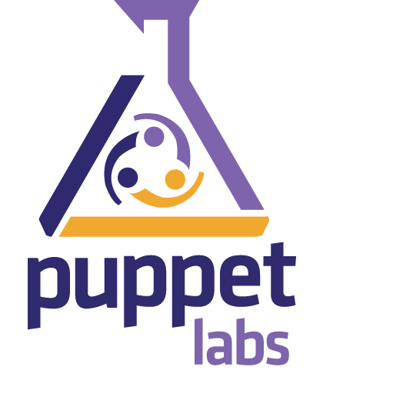
Puppet has been in use since 2005. Many organizations, including Google, Twitter, Oracle, and Rackspace, use it to manage their infrastructure. Puppet, which tends to require a steeper learning curve than Chef, supports a variety of Windows and *nix environments. Puppet has a large and active user community. It has been used in thousands of organizations with installations running tens of thousands of instances.

3.2.1 How it works
Puppet uses the concept of a master server — called the Puppet master — which centralizes the configuration among nodes and groups them together based on type. For example, if you had a set of web servers that were all running Tomcat with a Jenkins WAR, you'd group them together on the Puppet master. The Puppet agent runs as a daemon on systems. This enables you to deploy infrastructure changes to multiple nodes simultaneously. It functions the same way as a deployment manager, but instead of deploying applications, it deploys infrastructure changes.

3.4 Ansible

Ansible is a radically simple IT automation engine that automates cloud provisioning, configuration management, application deployment, intra-service orchestration, and many other IT needs.
Designed for multi-tier deployments since day one, Ansible models your IT infrastructure by describing how all of your systems inter-relate, rather than just managing one system at a time.
It uses no agents and no additional custom security infrastructure, so it's easy to deploy - and most importantly, it uses a very simple language (YAML, in the form of Ansible Playbooks) that allow you to describe your automation jobs in a way that approaches plain English.

3.4.1 Architecture
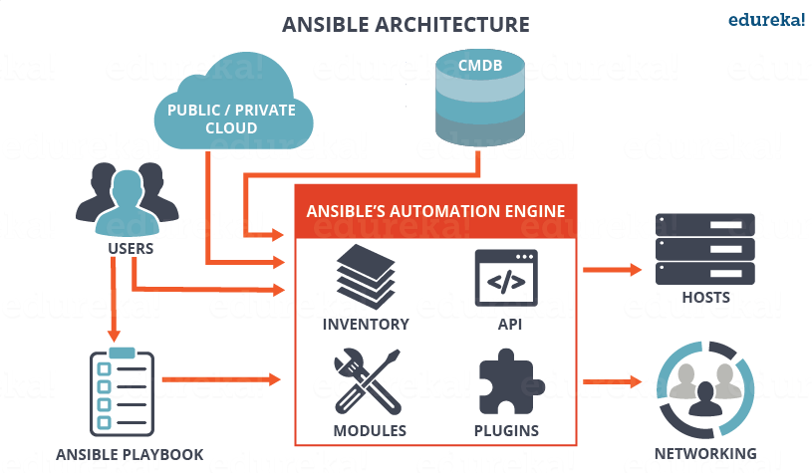
Ansible works by connecting to your nodes and pushing out small programs, called "Ansible modules" to them. These programs are written to be resource models of the desired state of the system. Ansible then executes these modules (over SSH by default), and removes them when finished.
Your library of modules can reside on any machine, and there are no servers, daemons, or databases required. Typically you'll work with your favorite terminal program, a text editor, and probably a version control system to keep track of changes to your content.

3.4.2 SSH Keys
Passwords are supported, but SSH keys with ssh-agent are one of the best ways to use Ansible. Though if you want to use Kerberos, that's good too. Lots of options! Root logins are not required, you can login as any user, and then su or sudo to any user.
Ansible's "authorized_key" module is a great way to use ansible to control what machines can access what hosts. Other options, like kerberos or identity management systems, can also be used.

3.4.3 Playbooks
Playbooks can finely orchestrate multiple slices of your infrastructure topology, with very detailed control over how many machines to tackle at a time. This is where Ansible starts to get most interesting.
Ansible's approach to orchestration is one of finely-tuned simplicity, as we believe your automation code should make perfect sense to you years down the road and there should be very little to remember about special syntax or features.

3.5 Salt
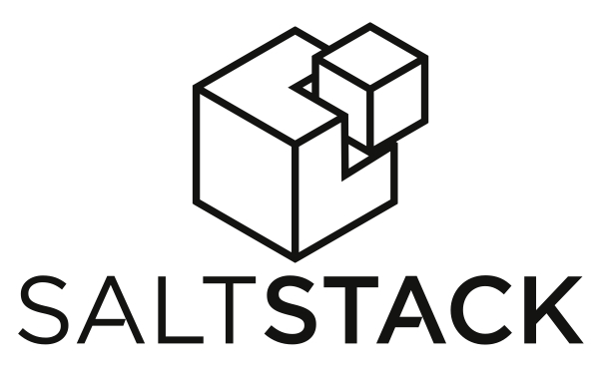
Salt was born as a distributed remote execution system used to execute commands and query data on remote nodes, or “minions”, either individually or by arbitrary selection criteria, or “targeting”.
Salt has been extended to a configuration management system, capable of maintaining remote nodes in defined states.
- master, the server that runs the core services to communicate with Salt minions. It also contains the key store for encryption between the minions.
- minions, the agents that run a micro version of Salt for local execution and communication back to the master.
- engines, Salt Engines are long-running, external system processes that leverage Salt.
- states, or formulas, files that contain YAML and templated data to configure minions. The templating engine is also very flexible. It’s not limited to Jinja, but also chetah, genshi, mako (very important for those from a Puppet background), wempy or even pure python.

2.5.2 Architecture
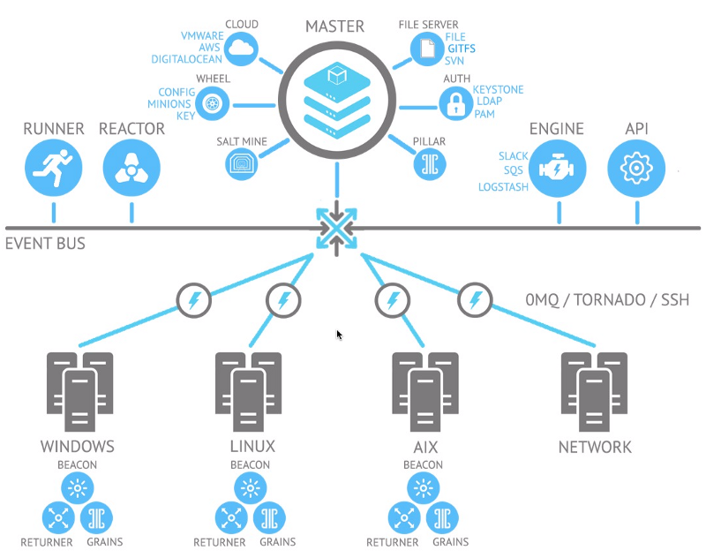
Salt’s architecture is based on a hub and spoke methodology. Some very large deployments have multi-master but this is quite rare. The master can easily scale to many thousands of nodes due in part to the lightweight message bus ZeroMQ. Other deployment models are
- A master-less setup
- Hierarchical masters able to communicate between them using syndic.
The master contains state files, which you would typically put in a shared storage volume. These are set up in a tree so that you can use targeting to specify groups of servers to configure and the environment/applications to deploy.
Salt’s event-based system is using beacons. Similar to StackStorm’s sensor and trigger system, Salt’s beacons fire events into the message bus which can then be dealt with in the reactor (on the master). The rules engine in the reactor is quite crude compared with StackStorm as you’re typically triggering a state or execution command off the back of a beacon firing an event. However, beacons run on the minions, so if you’re detecting events on the servers this is straight-foward. Because StackStorm and Ansible are agent-less this is a unique feature for Salt.

2.6 Travis CI tool

2.6.1 About

Travis CI is a hosted, distributed continuous integration service used to build and test software projects hosted at Github.
Travis CI is configured by adding a file named .travis.yml, which is a YAML format text file, to the root directory of the repository. This file specifies the programming language used, the desired building and testing environment (including dependencies which must be installed before the software can be built and tested), and various other parameters.
When Travis CI has been activated for a given repository, GitHub will notify it whenever new commits are pushed to that repository or a pull request is submitted. It can also be configured to only run for specific branches, or branches whose names match a specific pattern. Travis CI will then check out the relevant branch and run the commands specified in .travis.yml, which usually build the software and run any automated tests. When that process has completed, Travis notifies the developer(s) in the way it has been configured to do so - for example, by sending an email containing the test results (showing success or failure), or by posting a message on an IRC channel. In the case of pull requests, the pull request will be annotated with the outcome and a link to the build log, using a GitHub integration.
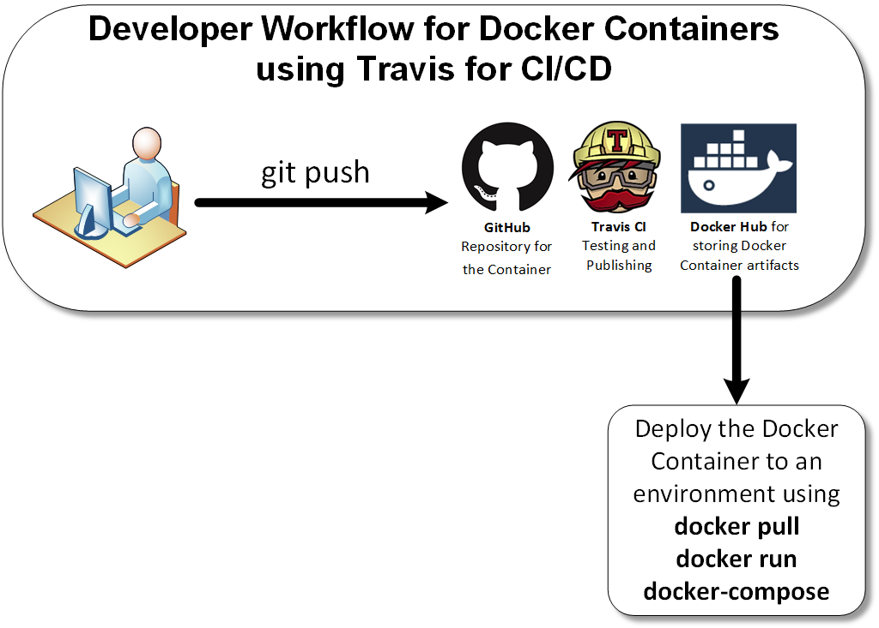

2.6 Jenkins

2.6.1 About

Jenkins is an open source automation server. With Jenkins, organizations can accelerate the software development process through automation. Jenkins manages and controls development lifecycle processes of all kinds, including build, document, test, package, stage, deployment, static analysis and many more.
You can set up Jenkins to watch for any code changes in places like SVN and Git, automatically do a build with tools like Ant and Maven, initiate tests and then take actions like rolling back or rolling forward in production.
Thanks to its extensibility and a vibrant, active community, Jenkins has grown significantly. Today the Jenkins community offers more than 1,300 plugins that allow Jenkins to integrate with almost any popular technology. It is by far the most dominant automation server and, as of December 2016, there are more than 133,000 active installations and an estimated 1+ million users around the world.

2.6.2 Architecture
Jenkins is primarily a set of Java classes that model the concepts of a build system in a straight-forward fashion (and if you are using Jenkins, you've seen most of those already). There are classes like Project, Build, that represents what the name says. The root of this object model is Hudson, and all the other model objects are reachable from here.
Then there are interfaces and classes that model code that performs a part of a build, such as SCM for accessing source code control system, Ant for performing an Ant-based build, Mailer for sending out e-mail notifications.

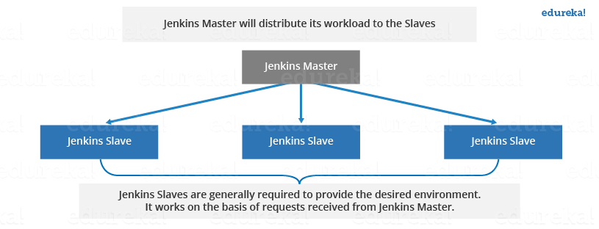
Jenkins Master
The main Jenkins server is the Master. The Master’s job is to handle:
- Scheduling build jobs.
- Dispatching builds to the slaves for the actual execution.
- Monitor the slaves (possibly taking them online and offline as required).
- Recording and presenting the build results.
- A Master instance of Jenkins can also execute build jobs directly.

Jenkins Slave
A Slave is a Java executable that runs on a remote machine. Following are the characteristics of Jenkins Slaves:
- It hears requests from the Jenkins Master instance.
- Slaves can run on a variety of operating systems.
- The job of a Slave is to do as they are told to, which involves executing build jobs dispatched by the Master.
- You can configure a project to always run on a particular Slave machine, or a particular type of Slave machine, or simply let Jenkins pick the next available Slave.

Jenkins Build Pipeline
It is used to know which task Jenkins is currently executing. Often several different changes are made by several developers at once, so it is useful to know which change is getting tested or which change is sitting in the queue or which build is broken. This is where pipeline comes into picture. The Jenkins Pipeline gives you an overview of where tests are up to. In build pipeline the build as a whole is broken down into sections, such as the unit test, acceptance test, packaging, reporting and deployment phases. The pipeline phases can be executed in series or parallel, and if one phase is successful, it automatically moves on to the next phase (hence the relevance of the name “pipeline”).
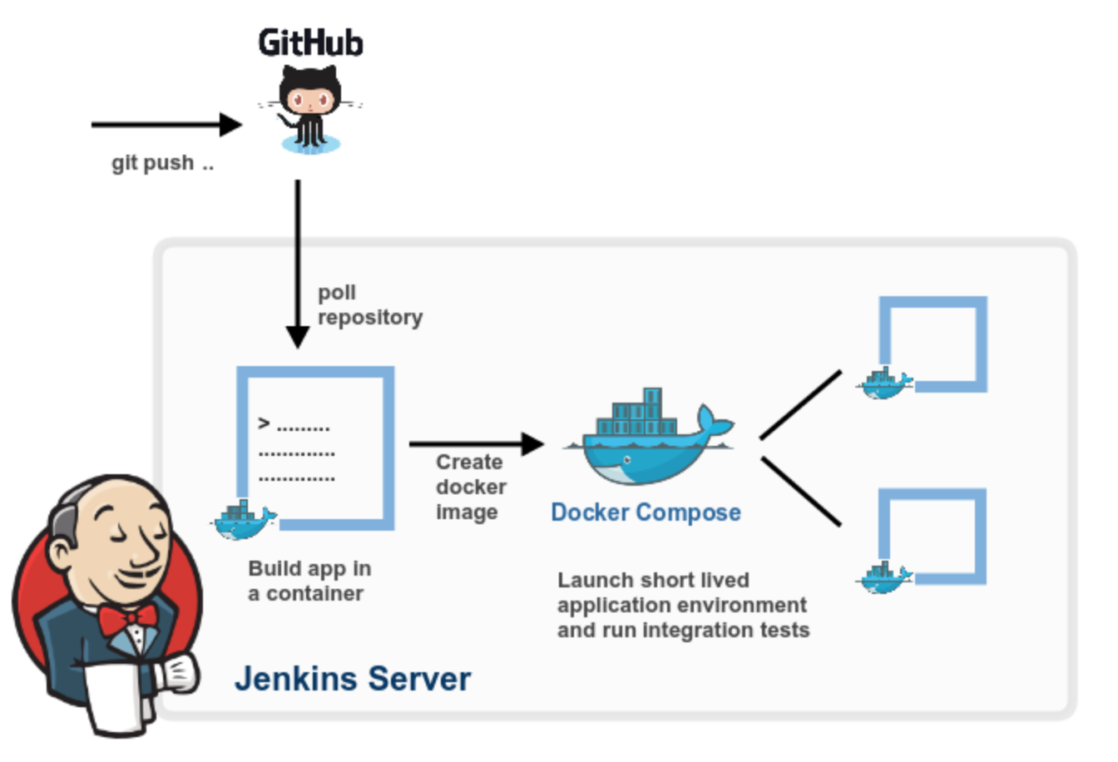

https://www.edureka.co/blog/jenkins-tutorial/

2.7 Slack

Slack is a notification and collaboration tool that you can use to gain visibility into everything that is happening in your project. When Slack and Jenkins are integrated, Jenkins can post build notifications to a Slack channel to notify team members about the status of the continuous delivery pipeline.
https://www.ibm.com/devops/method/content/deliver/tool_jenkins/

2.8 TeamCity
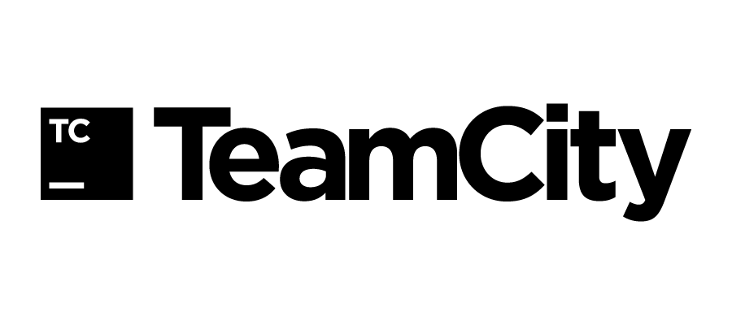
TeamCity is a server-based Web application that allows Java and .NET development teams to continuously integrate changes to the code base, frequently run distributed builds and tests, check and improve code quality, all the while making efficient progress toward successful project completion. TeamCity includes many productivity plugins for IntelliJ IDEA, Microsoft Visual Studio and Eclipse, which improves team collaboration without breaking the established practices, by separating creative work from routine tasks.
https://www.componentsource.com/product/teamcity/about

2.9 Rational Team Concert
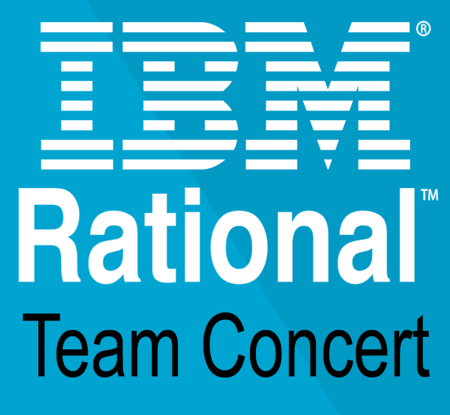
Rational Team Concert helps companies build better software and products with an all-in-one agile environment for development teams. This includes agile, formal and hybrid planning and reporting that are all on a common platform.
This solution offers no-charge server software and flexible pricing models. It also offers role-based licensing and multiple platform support in a single release, allowing you to implement individual components now and in the future.
In addition, Rational Team Concert provides collaborative change management capabilities. These capabilities are available separately and can be integrated with popular source control systems.
Rational Team Concert helps teams collaborate for faster software delivery.
- Enhances team collaboration with integrated features including work-item, build and software configuration management.
- Provides high visibility into project activities and team progress with multilevel dashboards and reporting features.
- Facilitates planning and execution of agile or formal projects with planning tools and templates, including a new Scaled Agile Framework (SAFe) template that is available in the latest version of Rational Team Concert.
- Helps improve productivity with advanced source control for geographically distributed teams.
http://www-03.ibm.com/software/products/en/rtc

4.10 Git lab

Strongloop

StrongLoop began in 2013 offering an open-source enterprise version of Node.js. Acquired by IBM in 2015, the StrongLoop team continues to build LoopBack, the open-source Node.js API Framework. IBM continues to contribute and support the StrongLoop community through these projects that provide key technologies for the API economy:

LoopBack project
LoopBack is a highly-extensible, open-source Node.js framework that enables you to:
- Create dynamic end-to-end REST APIs with little or no coding.
- Access data from major relational databases, MongoDB, SOAP, and REST APIs.
- Incorporate model relationships and access controls for complex APIs.
- Use separable components for file storage, third-party login, and OAuth 2.0.

Microgateway
The Microgateway is an extensible gateway framework written in Node.js for enforcing access to Microservices and APIs. It supports the following core features:
- Secure and control access to APIs using Swagger (OpenAPI) Specification
- Collection of pre-built gateway policies for API Key validation, OAuth 2.0, rate limiting, and JavaScript
- Create gateway policies (security, routing, integration, etc... ) using Swagger extensions (API Assembly)
- Simple interfaces for creating your own gateway policies.
The role of a Gateway in an API architecture is to protect, enrich and control access to API services. These sets of capabilities are often related to security and rate limiting, but it also includes the ability to do deeper message inspection. For example, you may want to insure that the message received is properly formed JSON, XML, or data following your own specific format. In addition, the Gateway can modify the payload or transform it to meet old or new interfaces for the API backend. Finally, the Gateway can invoke multiple services and aggregate responses from multiple API backends.

Open API
The Open API Initiative (OAI) was created by a consortium of forward-looking industry experts who recognize the immense value of standardizing on how REST APIs are described. SmartBear Software is donating the Swagger Specification directly to the OAI as the basis of this Open Specification. APIs form the connecting glue between modern applications. Nearly every application uses APIs to connect with corporate data sources, third party data services or other applications. Creating an open description format for API services that is vendor neutral, portable and open is critical to accelerating the vision of a truly connected world.

Continuous Delivery

.10 Urbancode Deploy

6.3 Smart campus open source project (DevOps)
Your goal will be to setup an open source project on Github. You will take on various responsibilities and carry out extensive research in the area of development and operations. This project, if successfully completed will provide students with the ability to develop and collaborate together on building microservices applications.
Primary objectives:
- Learn how to use Git version control
- Study at least 2 open source projects (e.g OpenWhisk and Istio)
- Setup your own repository using what you have learned from the case studies
Secondary objectives:
- Study microservices and how they can all be managed from a single repository
- Study continuous integration/delivery pipelines
- Study the Jenkins build tool (or something similar)
- Deploy your very own integration pipeline
- Integrate at least 1 testing framework (e.g Mocha.js)
- Demonstrate automated tests executed after making a commit to the repository
- Demonstrate what happens when a test is failed vs succeeded
- Demonstrate how another student can make a commit to the repository
Responsibilities:
- You will demonstrate your administrative control over the repository.
- Provide sufficient documentation and instructions so that future students can easily start working on their own smart campus microservices without conflicting with others work.

6.4 Smart campus mobile applications using Ionic library
Ionic is a powerful HTML5 SDK that helps you build native-feeling mobile apps using web technologies like HTML, CSS, and Javascript. Ionic currently requires AngularJS in order to work at its full potential.
Ideally your application should use mqtt to interact with a node.js backend or RESTful microservices.
Primary objectives:
- Create a prototype app that has a detailed view of the UL campus and class rooms
- The app communicates with Istio microservices to get current statistics (e.g number of people)
- The map UI is updated regularly
- Sections of the map are updated independently by individual microservices (e.g Schuman Service)
Secondary objectives:
- Prototype for Library (e.g feature for notifying user about available desks)
- Prototype for Gym (e.g feature for notifying user about available threadmills)
- Prototype for Car park (e.g feature for notifying user about available spaces)
Link to Ionic/Mosca integration:
https://blog.codecentric.de/en/2014/09/home-pi-reloaded-home-automation-ionic-mqtt/

6.5 Library,car park, Gym sensor/public API
Using Istio, develop an API that will handle the data flow coming from Library, car park and Gym Sensors.
Primary Objectives:
- Sensors should be able to call the sensor API to transmit and store data.
- Sensors should be able to call public API to get data readings
Secondary Objectives:
- Demonstration of service version controlling (v1, v2, v3)
- Demonstration of load balancing modes ( round robin, random, and weighted least request)
- Demonstration of service policy and control (e.g only bob can use serviceBob)

6.6 Graph database design for both a WSN and/or student survey application
Using mocked WSN/survey data, your objective is to design a suitable graph database for WSN and student surveys.
Objectives:
- Study graph databases
- Study Gremlin ( a graph traversal language)
- Draw up a graph schema for survey info (e.g linking gender with department nodes)
- feed data to Watson
- train Watson

6.7 Migration of a monolithic app to a microservices app using Istio
Your objective is to take a reasonably large monolithic application and break it down into microservices using Istio.

https://community.rapid7.com/community/metasploit/blog/2013/07/02/a-penetration-testers-guide-to-ipmi
http://fish2.com/ipmi/bp.pdf

https://community.rapid7.com/docs/DOC-2344

*******************************/
https://www.ibm.com/developerworks/library/a-devops2/index.html

devops tools ansible, salt
https://medium.com/@anthonypjshaw/ansible-v-s-salt-saltstack-v-s-stackstorm-3d8f57149368

2.2 Dan Geer on Open Source and IoT security related issues

2.2.1 Cybersecurity as Realpolitik by Dan Geer
At the Black Hat cybersecurity conference in 2014, industry luminary Dan Geer made a modest proposal: Software companies should either make their products open-source so therefore buyers can see what they are getting and tweak what they don’t like, or suffer the consequences if their software failed. He compared it to the ancient Code of Hammurabi, which states that if a builder poorly constructs a house and the house collapses and kills its owner, the builder should be put to death.
Putting sloppy programmers to death is not the solution, but holding software companies liable for defective programs, and nullifying licensing clauses that have effectively disclaimed such liability, may make sense, given the increasing prevalence of online breaches.
“The obvious policy stance, if Company X abandons a code base, then that code base must be open sourced. Irrespective of security issues. But with respect to security, some constellation of {I,we,you,they} are willing and able to provide security patches or workarounds as time and evil require. Open-sourcing abandoned code bases is the worst option, except for all the others. But if seizing an abandoned code base is too big a stretch for you before breakfast, then start with a Public Key Infrastructure Certifying Authority that goes bankrupt and ask “Who gets the keys?” ”

2.2.2 Dan Geer on the Internet of Things
Amongst deployed monocultures, computer desktops are not the point; embedded systems are. The trendline in the count of critical monocultures seems to be rising and most of these are embedded systems both without a remote management interface and long lived. That combination -- long lived and not reachable -- is the trend that must be dealt with, possibly even reversed. Whether to insist that embedded devices self destruct by some predictable age or that remote management of them be a condition of deployment is the question, dare I say the national policy question, that is on the table. In either case, the Internet of Things, which is to say the appearance of network connected microcontrollers in seemingly every device, should raise hackles on every neck.
“An advanced persistent threat, one that is difficult to discover, difficult to remove, and difficult to attribute, is easier in a low-end monoculture, easier in an environment where much of the computing is done by devices that are deaf and mute once installed or where those devices operate at the very bottom of the software stack, where those devices bring no relevant societal risk by their onesies and twosies, but do bring relevant societal risk at today's extant scales much less the scales coming soon.”
“Perhaps what is needed is a way to reach out and upgrade the endpoints when the time of necessity comes. But today, or real soon now, most of the places needing a remote management interface through which you can remotely upgrade the endpoints are embedded hardware.”
“Resiliency is an area where no one policy can be sufficient, so I've suggested a trio of baby steps: embedded systems cannot be immortal if they have no remote management interface, embedded systems must have a remote management interface if they are to be immortal, and swap-over is preferable to swap-out when it comes to data protection.”
http://geer.tinho.net/geer.secot.7v14.txt
https://www.privacywonk.net/2014/11/cybersecurity-as-realpolitik-by-dan-geer.php

